

HELWAN UNIVERSITY
Faculty of Computers and Artificial Intelligence

IS 351 System Analysis and Design-1
Project

Electronic Shop Management System

December 2025

Table of contents:
- Abstract……………………………………………………………………….
- Introduction…………………………………………………………………...
- Objectives…………………………………………………………………….
- Scope………………………………………………………………………….
- Requirements………………………………………………………………….
  - Functional requirements………………………………………………….
  - Non-functional requirements……………………………………………...
- Actors…………………………………………………………………………
- Use cases overview…………………………………………………………...
- System Diagrams……………………………………………………………...
- Use cases Diagrams (Activity and Sequence)………………………………...
  - Login……………………………………………………………………….
  - Register…………………………………………………………………….
  - Search Products…………………………………………………………….
  - Admin……………………………………………………………………..
  - Add to Cart………………………………………………………………...
  - Checkout………………………………………………………………......

- Abstract
The Electronic Shop is a specialized digital platform designed to streamline the sale of consumer electronics, including phones, laptops, tablets, and computer accessories. It automates the entire customer journey—from account registration and secure login to product discovery and final purchase. The system connects customers directly with the shop’s inventory of tech gadgets, ensuring that stock levels for high-demand items like smartphones and mice are managed in real-time. By digitizing the sales process, the Electronic Shop ensures accuracy in order processing and provides a seamless shopping experience for tech enthusiasts.
- Introduction
The Electronic Shop is an integrated web-based system designed to support the daily operations of an online electronics retailer. The system focuses on automating core tasks such as creating user accounts, authenticating customers, and managing a digital catalog of products ranging from high-end laptops to essential peripherals like mice. Instead of manual inventory tracking, the Electronic Shop centralizes data so that product specifications, prices, and availability are instantly accessible. This ensures that customers can easily find the latest tablets or phones, add them to a secure digital cart, and finalize their purchase efficiently.
- Objectives
The Electronic Shop aims to improve the efficiency of selling electronic goods online by providing a structured and reliable digital workflow. The main objectives are:

- Enhance Shopping Experience: Provide a smooth interface for users to browse technical specifications and purchase devices without navigational delays.
- Improve Inventory Accuracy: Ensure that stock levels for specific items (e.g., a specific model of laptop or phone) are validated in real-time to prevent overselling.
- Streamline Sales Operations: Automate the flow from "Add to Cart" to "Order Confirmation," reducing the manual workload for shop administrators.
- Secure Transactions: Implement robust authentication and secure checkout processes to protect high-value transactions and user data.
- Scope
The Electronic Shop system covers the essential activities required for an online electronics store.
- The system handles Customer Registration and Login, securing access to personal order history.
- It supports Product Discovery, allowing users to search for specific gadgets (e.g., "Gaming Laptop", "Wireless Mouse").
- It manages Cart Operations, such as selecting the quantity of devices and validating stock availability before purchase.
- It handles the Checkout Process, capturing shipping addresses for delivery and processing payment methods.
- It focuses on the interaction between the Customer, the Web Interface, and the Backend System (Database, Auth, and Cart Services).

- Requirements
The system requirements are divided into two main categories: Functional Requirements (what the system must do) and Non-Functional Requirements (how the system should perform). These requirements are based directly on the use cases and system scope.

  - Functional Requirements
The system must support the essential operations of an electronics retailer. The main functional requirements are:
- User Management
  - The system must allow new Customers to register by entering their personal information.
  - The system must allow registered users to log in securely using their credentials.
- Product Management
  - The system must allow users to search for devices by name or category (e.g., "Phone", "Tablet") and view technical details.
- Cart Management
  - The system must allow users to add multiple items (e.g., a laptop and a mouse) to the cart and automatically check inventory limits.
- Order Processing
  - The system must allow users to input delivery details, select a payment method, and generate a receipt upon successful transaction.
- Billing and Payment Processing
  - The system must generate bills based on completed services.
- Administrative Management
  - The system must allow administrators to manage staff accounts (e.g., adding or removing Products).
  - The system must generate basic internal reports for administrative use (e.g., Products count, Users visits, daily summaries).
  - Non-functional Requirements
- Performance
  - lazy load product images, paginate product lists, debounce search requests.
- Usability
  - Interfaces should be simple and easy to use.
- Reliability
  - The system must save information consistently and avoid unexpected data loss.
- Security
  - sanitize user inputs, store tokens carefully, use HTTPS for API calls.
- Maintainability
  - The system should be structured in a way that allows future updates and modifications without affecting the rest of the system.
- Actors
List of main actors and their responsibilities:
- Guest: Browses products, searches, adds items to cart, can register or checkout as guest (if allowed).
- Customer (Registered User): Logs in, manages account, places orders, writes reviews.
- Backend API (System): Provides product data, handles auth and order creation. Treated as an external actor in diagrams.
- Admin: Manages products and inventory through a separate admin interface.
- Use Cases Overview
Simple table showing Use Cases, their actors, and a short description:

Use Case | Actor | Brief Description
Register/ Login | Guest | Guest creates an account or logs in to use the  system
Search Products | Guest/Customer | Search and filter catalog to find products.
Add to Cart | Guest/Customer | Add items to shopping cart and manage quantities.
Checkout | Customer/Guest | Submit shipping and create order.
View Product | Guest/Customer | Open product detail page.

Submit Review | Customer | Add product review and rating.

- System Diagrams
  - Class Diagram: Shows main entities (User, Customer, Admin, Product, Category, ShoppingCart, CartItem, Order, OrderItem, Payment, Feedback, etc.) and their relationships.

Diagram brief description:
This Class Diagram is a structural blueprint for an E-commerce Website. It organizes the system's data into key entities (classes) like User, Customer, Admin, and Product. The diagram details the processes around the shopping workflow, including adding Products to a ShoppingCart, placing Orders, processing Payments, managing Inventory, and submitting Feedback or Reviews.
It also illustrates the relationships between users and their Orders, the association of Products with Categories and CartItems, and the inheritance of Customer and Admin from the generic User class.
Finally, it shows how the system handles supporting components such as Notifications, Wishlist, and Reports, using lines to clearly define the specific relationships and multiplicities between these core components.

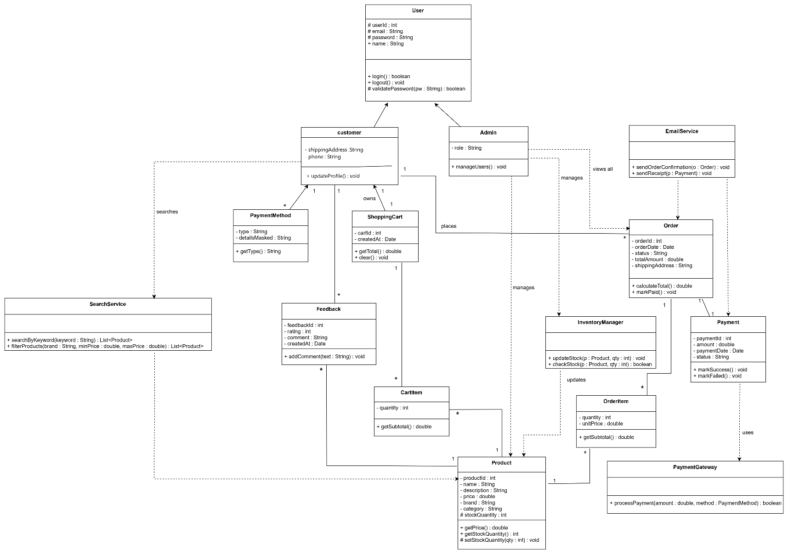
Diagram 1.Class Diagram for Electronic Shop Management System

  - Use Case Diagram: Visualizes all actors and the use cases they can perform.

Diagram brief description:
This Use Case Diagram outlines the functional requirements of the E-commerce Website. It identifies the system's users (Actors) such as Customer, Admin, and Guest. The diagram then maps out the system's capabilities (Use Cases—e.g., Browse Products, Add to Cart, Place Order, Make Payment, Submit Feedback) and shows how they relate.
Key functions include managing product listings, handling shopping carts, processing orders and payments, managing user accounts, submitting reviews and feedback, and performing administrative tasks like inventory management, generating reports, and managing user roles and permissions.
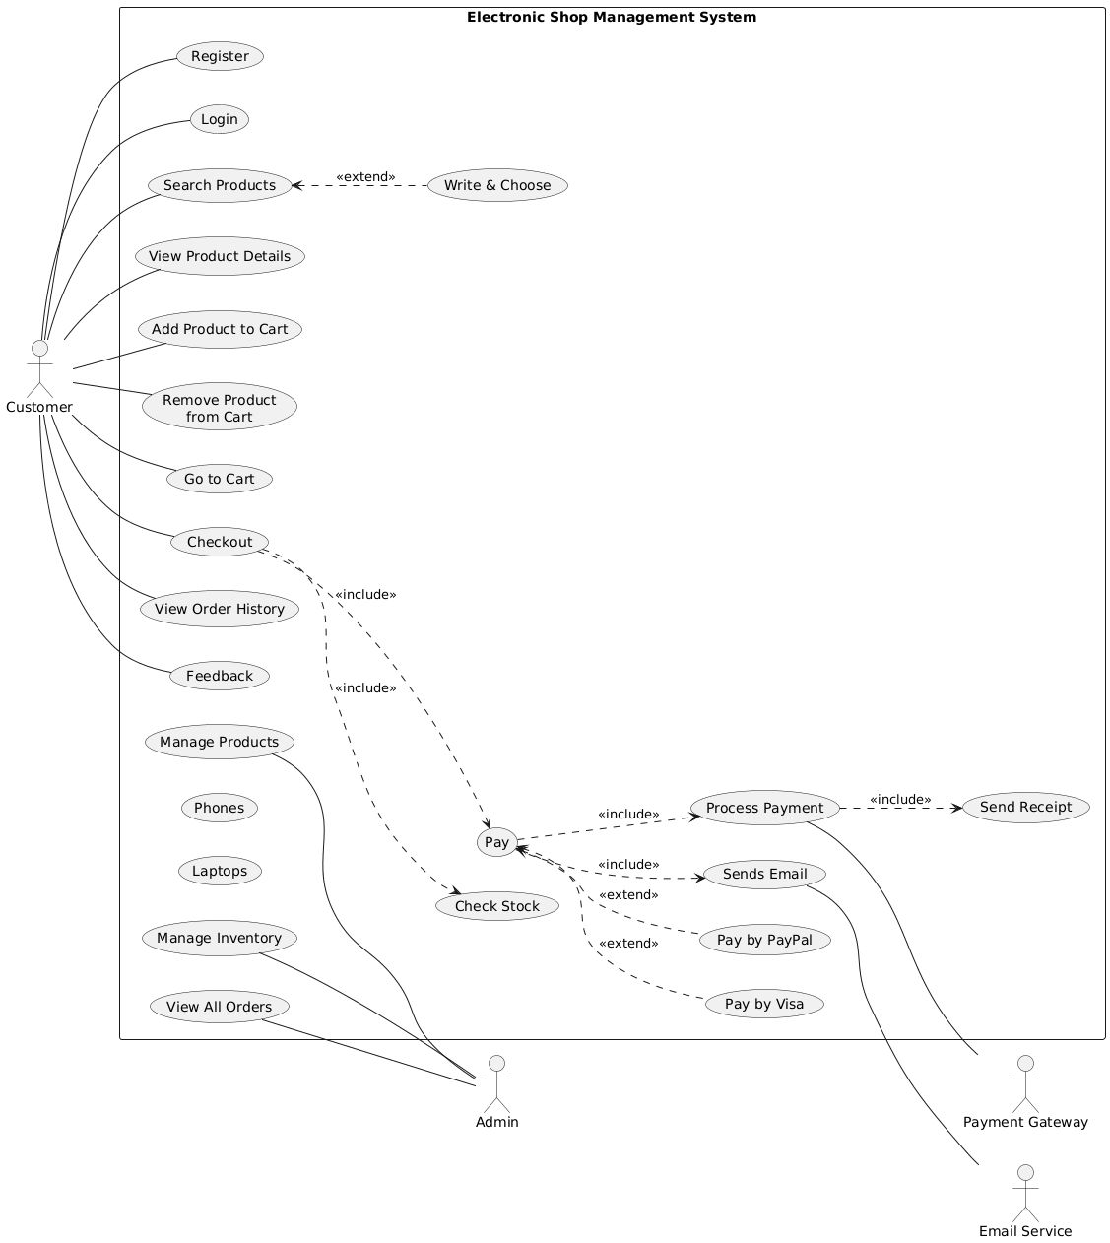
Diagram 2.Use Case Diagram for Electronic store Management System

  - DFD Level 0 (Context Diagram): Displays the system as a single process with data flows to and from external actors.

Diagram brief description:
The Level 0 Data Flow Diagram represents the Electronic Store System as a single high-level process that interacts with three entities: the Customer, the Admin, and the Payment Gateway. Customers send registration and login information, product search requests, and checkout data to the system, which returns account responses, product details, and order information. The admin provides management inputs such as user updates and product modifications and receives system feedback and reports. The system also communicates with the Payment Gateway by sending payment requests and receiving payment confirmations. This diagram shows the overall data exchange between the system and its external actors without detailing internal processes.

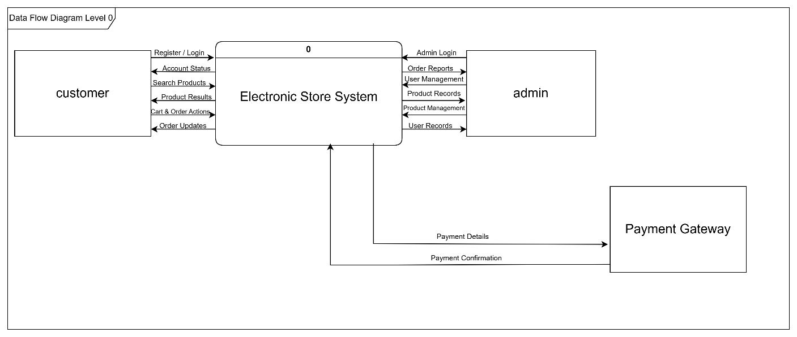

Diagram 3.Data Flow Diagram (Level 0) or Context Diagram for Electronic Shop Management System

  - DFD Level 1: Breaks the main process into sub-processes and includes data stores.

Diagram brief description:
A Level 1 data flow diagram breaks the whole e-commerce system into its major internal processes and shows how data moves between them, the external actors, and the data stores. In the diagram, Level 1 shows processes such as User Management, Product Management, Shopping & Ordering Management, Reporting/Administration, and Payment Processing, together with the customer, admin, payment gateway, and the related databases they read from or update.
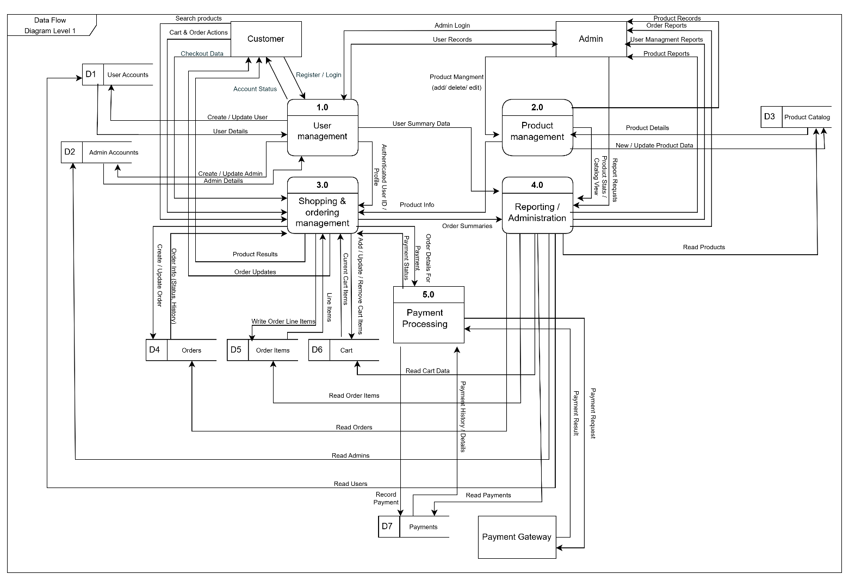

Diagram 4.Data Flow Diagram (Level 1) for Electronic Shop Management System

- Use Cases Diagrams (Activity and Sequence)
The following sections provide a detailed breakdown of each actor's responsibilities. For each actor, their associated use cases are described in full detail, followed by activity and sequence diagrams. This actor-centric organization makes it easier to understand how the system works and how actors interact with it.
First : we have Login Use Case (For all Actors)

Item | Description
Use case name | Login
Scenario | A registered user (e.g., Customer) enters username/email and password to access the Electronic Shop Management System.

Item | Description
Triggering event | The user opens the website and selects the "Login" option from the start page.
Brief description | The user provides login credentials. The system verifies them and, if valid, grants access to the dashboard; otherwise, it shows an error  message.
Primary actor | Customer (Registered User)
Stakeholders | Customers, Shop Management
Related use cases | Register, Logout, Forgot Password.
Preconditions | 1) The user is already registered in the system. 2) The system and database are available.
Postconditions | 1) The user becomes logged in with an active session. 2) The user is redirected to the appropriate home page (e.g., Account Dashboard).
Flow of activities (normal flow) | 1) Actor: Opens the system and clicks "Login". 2) System: Displays the login form (username/email and password). 3) Actor: Enters credentials and clicks "Login". 4) System: Validates the credentials against the  database. 5) System: If valid, creates a session and redirects the user to the dashboard.
Alternate /  Exception flow | 1) If username or password is incorrect: System displays "Invalid  username or password" and asks the user to try again. 2) If any required field is empty: System displays "Please fill all required fields". 3) If there is a database/connection error: System displays a general error  message and asks the user to try again later.

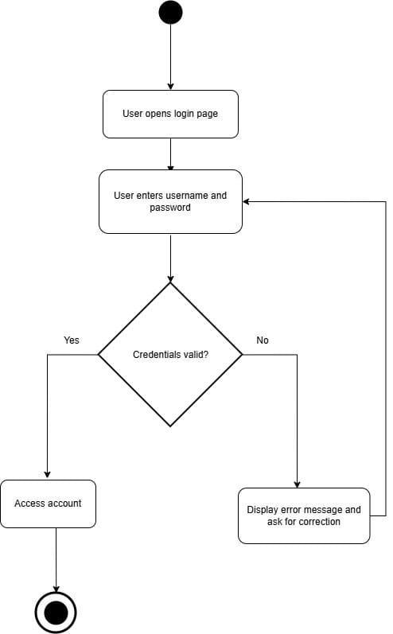
Activity Diagram for Login

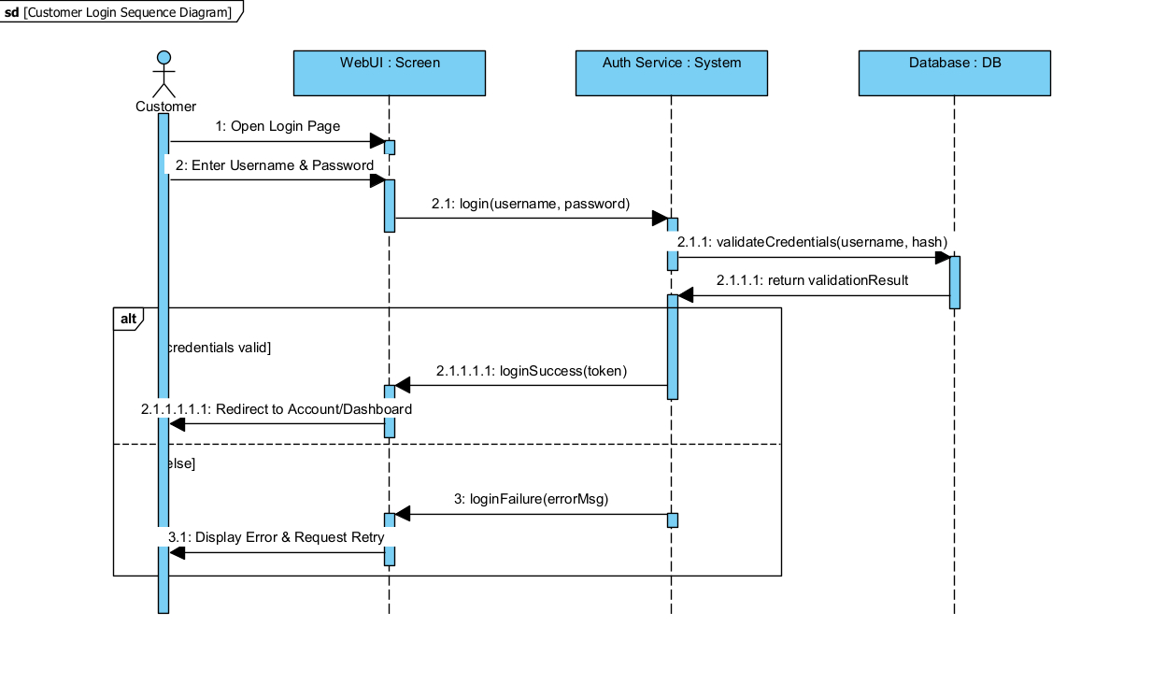
Sequence Diagram for Login

  - Customer
    - Use case : Register

Field | Description
Use Case Name | Register customer account
Scenario | A new customer wants to create an Electronic Shop account for the first time.
Triggering Event | Customer opens the website and selects “Register”.
Brief Description | Customer enters required personal information. The system validates the data and, if valid, creates a new customer account and displays a confirmation message.
Actor | Customer (Guest)
Related Use Cases | Login, Add to Cart, Checkout
Stakeholders | Customers, Shop Management
Preconditions | - Customer is not already registered.  • System and authentication service are available.
Postconditions | - New customer record is created.  • Customer login credentials are linked to the account.  • A success message is displayed.
Flow of Activities | Actor: Opens website → selects “Register” → enters personal data (name, email, password) → submits.  System: Displays registration form → validates all fields → checks if email already exists → creates customer record → shows confirmation message.

Activity Diagram:

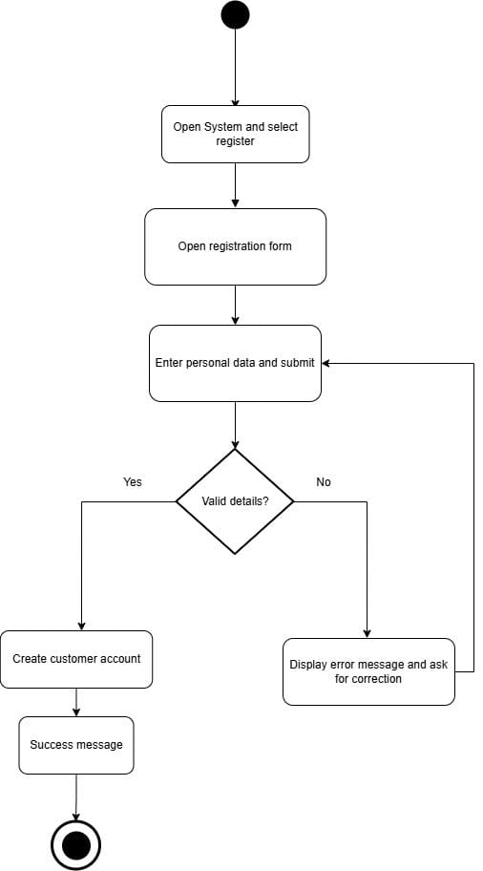

Sequence Diagram:

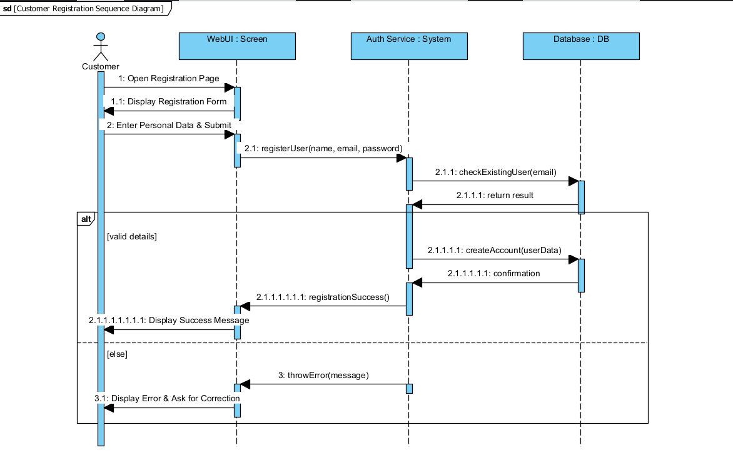
    - Use case : Search Products

Field | Description
Use Case Name | Search for Products
Scenario | A customer wants to search for a specific electronic product (e.g., phone, laptop, smartwatch) using keywords or filters
Triggering Event | Customer clicks the search bar or selects a category/filter.
Brief Description | Customer enters a keyword or selects filters → system processes the query → displays matching products from the catalog.
Actor | Customer
Related Use Cases | View Product Details, Add to Cart, Filter Products
Stakeholders | Customers, Shop Management
Preconditions | • Customer is on the website (logged in or guest).  • Product catalog exists in the system.
Postconditions | • Search results are displayed based on the user query.  • System may update “recent searches” or logging.
Flow of Activities | Actor: Enters search keyword OR selects filters (brand, category, price range).  System: Processes the query → retrieves matching products → displays results.
Exception Conditions | • No matching products → System shows “No products found” and suggests alternatives.  • Empty/invalid input → System requests a valid keyword.

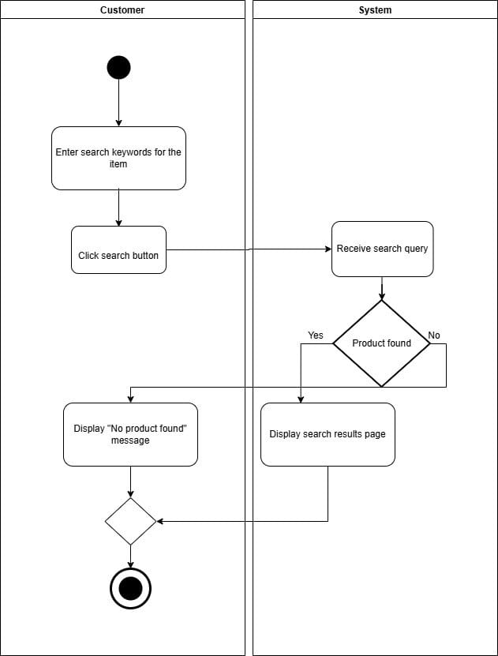
Activity Diagram

Sequence Diagram

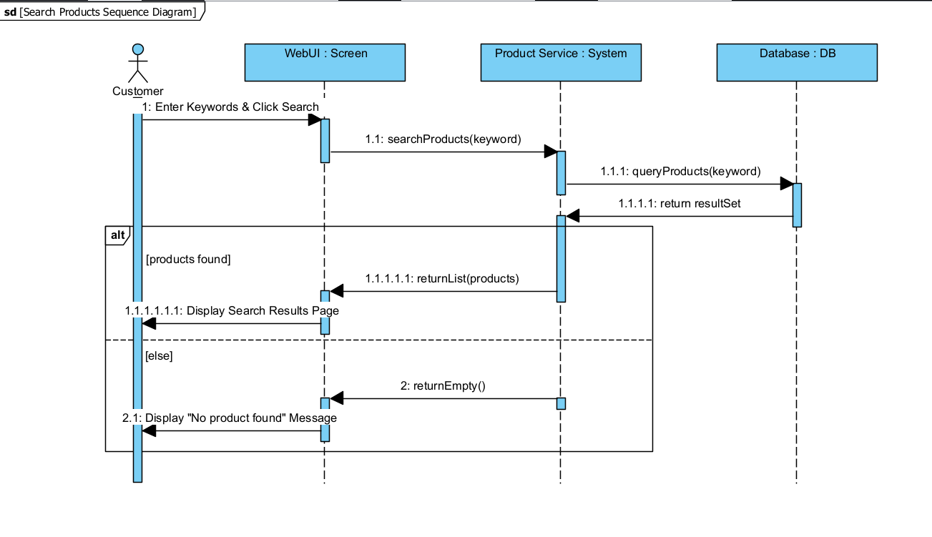

    - Use case : Add Product to Cart

Field | Description
Use Case Name | Add Product to Cart
Scenario | A customer wants to add an electronic product (e.g., phone, laptop, smartwatch) to their shopping cart.
Triggering Event | Customer selects a product and clicks “Add to Cart”.
Brief Description | The system retrieves the selected product details and adds it to the customer’s cart. If the product already exists in the cart, the system increases the quantity.
Actor | Customer
Related Use Cases | View Cart, Remove Item, Checkout
Stakeholders | Customers, Shop Management
Preconditions | - Customer is on a product page or search results page.  • Product exists in the system’s catalog.  • Product stock is available.
Postconditions | • Product is added to the customer’s shopping cart.  • Cart is updated (quantity / item count).  • No product data is modified (only cart state changes).
Flow of Activities | Actor: Clicks “Add to Cart” on the selected product.  System: Retrieves product details → checks stock availability → adds item to the cart → updates cart summary.
Exception Conditions | • Product is out of stock → system displays “This item is currently unavailable”.  • System error retrieving product → system shows “Unable to aadd item, please try again”.

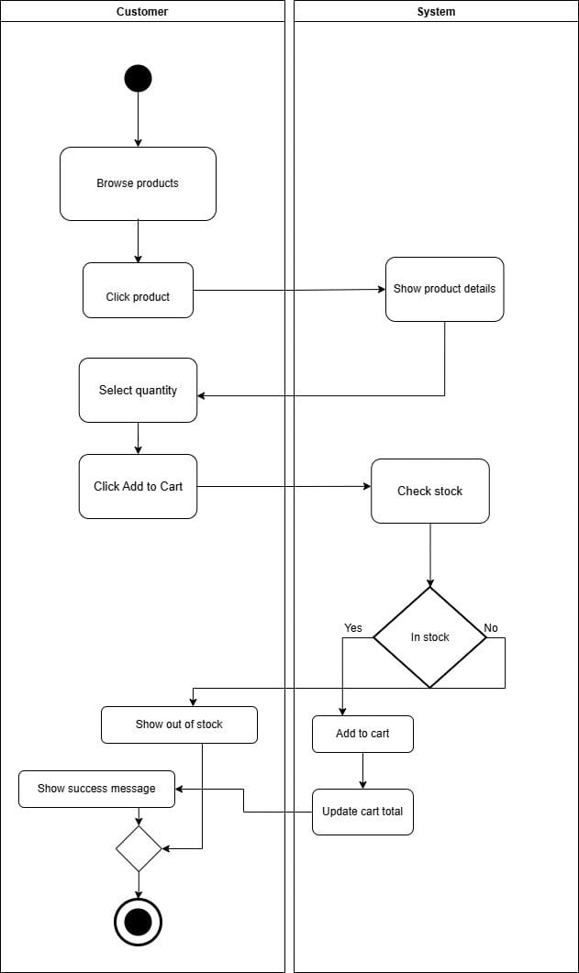
Activity Diagram
Sequence Diagram

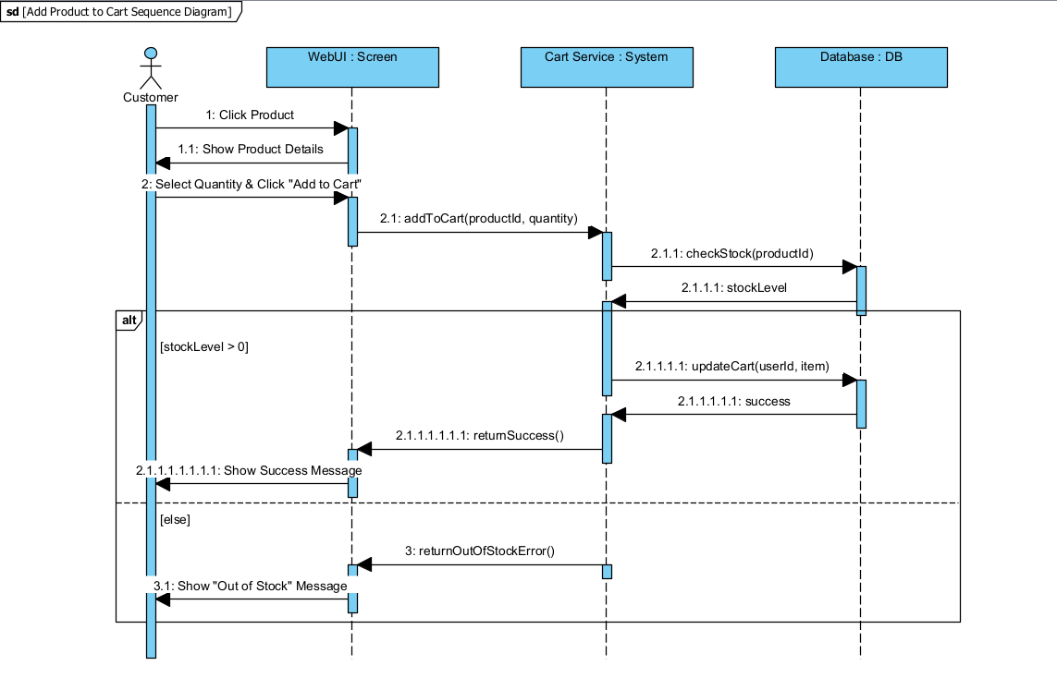

  - Customer
    - Use case : Checkout Payment

Use case name: | Checkout Payment
Scenario: | Customer finalizes an order and pays for items in the shopping cart
Triggering event: | Customer clicks "Proceed to Checkout" from the shopping cart
Brief description: | The customer reviews the order, selects a shipping address and payment method, enters payment details, and the system validates the transaction with the payment gateway to finalize the purchase.
Actors: | Customer (Primary), Payment Gateway (External System)
Related use cases: | Manage Shopping Cart, Login/Register, Send Order Confirmation
Stakeholders: | Customer, Sales Department, Inventory Manager, Accounting/Finance
Preconditions: | • The system must be available.  • The user is logged in (or enters guest details).  • The shopping cart must contain at least one item.  • Items in the cart must be in stock.
Postconditions: | • Payment is successfully processed.  • An Order ID is generated and saved.  • The shopping cart is cleared.  • Inventory quantities are updated.  • A receipt/confirmation is sent to the customer.
Flow of Activities : | Actor (Customer) System  -Customer initiates checkout by clicking "Proceed to Checkout".  1.1 System validates inventory availability.  1.2 System retrieves saved shipping addresses (if logged in) or requests address entry.  -Customer confirms/enters shipping address.  2.1 System calculates shipping costs and tax based on the address.  2.2 System displays the Order Summary (Total Amount).  - Customer selects payment method (e.g., Credit Card) and enters details.  3.1 System validates the format of the payment details.  3.2 System sends payment request to the Payment Gateway.  3.3 Payment Gateway processes the transaction and returns a "Success" token.4.  -Customer views the completion screen.  4.1 System records the order as "Paid".  4.2 System clears the user's cart.  4.3 System displays "Order Placed Successfully" with an Order ID.
Exception conditions: | 3.3 Payment Declined → Payment Gateway returns "Insufficient Funds" or "Invalid Card." System displays "Payment Failed: Please use a different method" and allows the user to retry step 3.  1.1 Item Out of Stock → System detects an item became unavailable during the session. System alerts the user "Item X is out of stock" and redirects back to the cart to remove the item.  3.2 System Timeout → The connection to the Payment Gateway times out. System displays "Transaction timed out, please try again later" and does not create the order.

Activity Diagram
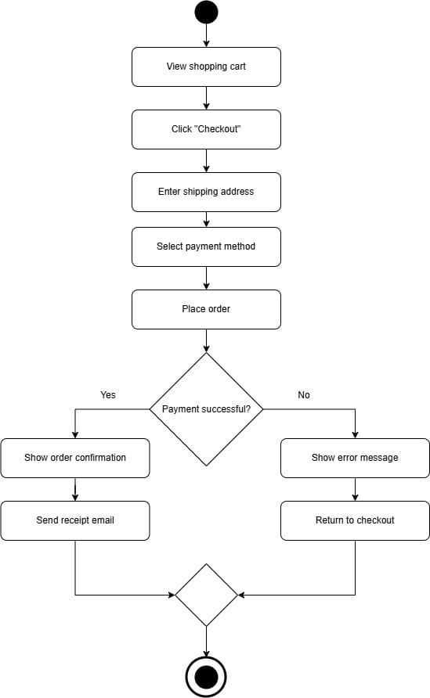

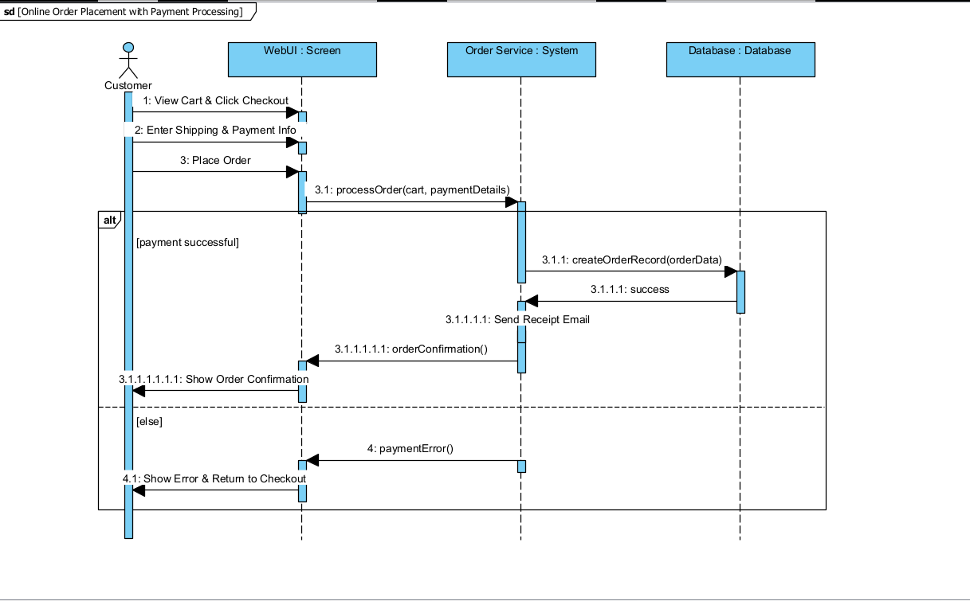
Sequence Diagram

